## Choosing an Appropriate Indicator for a Titration

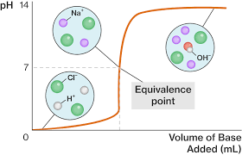An appropriate indicator will change colour at the **equivalence point** of the titration. The equivalence point represents the point when the **neutralisation reaction is complete**.

* Litmus is not used in titrations because the pH range over which it changes colour is too great.
* Universal is not used for titrations, as the colour changes are gradual. An indicator is suitable for a titration should ideally sudden colour change.

**Step 1**

Determine the approximate pH of the equivalence point.

The table below gives you some idea of the relative pH at the equivalence point for acid-base titrations based on the relative strength of the acids and bases:

|  |  |  |
| --- | --- | --- |
| **pH of salts formed from reactions of acids & bases (25oC)** | **Strong Base** | **Weak Base** |
| **Strong Acid** | pH = 7 | pH < 7 |
| **Weak Acid** | pH > 7 | pH ≈ 7 |

**Step 2**

Use the table of indicators to choose an indicator that changes colour over a pH range that includes the equivalence point

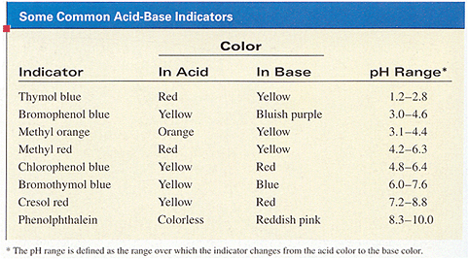

### https://previews.123rf.com/images/72soul/72soul1209/72soul120900043/15327816-Illustration-depicting-a-roadsign-with-a-jargon-concept-White-background--Stock-Illustration.jpg

### **Titration Curve**

A titration curve is a graph obtained from a titration of pH versus volume of reactant added from a burette.

### **Titration Examples**

### **Strong Acid-Strong Base Titration**

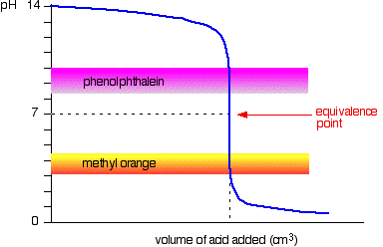

Example (the titration of a NaOH solution using a HCl standard solution)

HCl(aq) + NaOH(aq) → NaCl(aq) + H2O(l)

At the equivalence point of the neutralisation reaction, the only species present will be NaCl(aq) and H2O(l). The aqueous solution of a salt of a strong acid and a strong base will have a pH = 7 at 25oC. Therefore NaCl(aq) will have a pH = 7

Phenolphthalein or methyl orange would work However, Bromothymol blue (pH range 6.2 - 7.6) and phenol red (pH range 6.8 - 8.4) are better choices for this neutralisation reaction

### http://www.chemguide.co.uk/physical/acidbaseeqia/wasbinds.gif**Weak Acid-Strong Base Titration**

Example (the titration of NaOH solution using a CH3COOH standard solution)

CH3COOH(aq) + NaOH(aq) → CH3COONa(aq) + H2O(l)

At the equivalence point CH3COONa(aq), the salt of a weak acid and a strong base, is present so a solution of CH3COONa will have a pH > 7 (CH3COO- is a weak base) 

Consider thymol blue (pH range 8.0 - 9.6) or phenolphthalein (8.3 - 10.0) as suitable indicators. Methyl orange would not work as a colour change of this indicator is too far from the equivalence point.

### **Strong Acid-Weak Base titration**

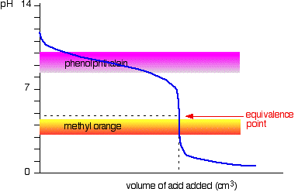

Example (The titration of an NH3 solution using a HCl standard solution)

HCl(aq) + NH3(aq) → NH4Cl(aq)

NH4Cl is the salt of a strong acid and a weak base, so a solution of NH4Cl will have a pH < 7 (NH4+ is a weak acid)

A suitable indicator would be methyl red (pH range 4.4 - 6.0). Phenolphthalein would be a poor choice.

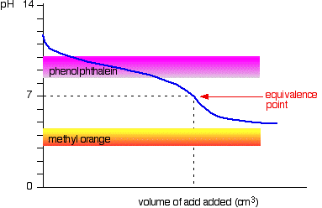

### **Weak Acid-Weak Base Titration**

This titration is rarely done as the change in pH is gradual and the end-point is difficult to determine with accuracy.

**Extension:**

* Indicators are simple acid-base equilibrium system. We can represent them by the foollowing equation:

HIn(aq) + H2O(l) ⇌ In−(aq) + H3O+(aq)

* 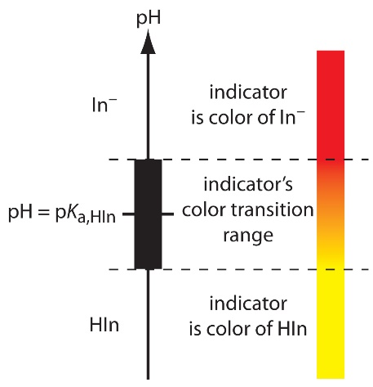The equilbrium constant (acidity constant) for this equation is:

Ka = [In−][H3O+]

[HIn]

* At the equivalence point [HIn] = [In-] are equal therefore Ka can be rewritten as:

Ka = [H3O+]

* Therefore, the pH of an indicators equivalence point can be determined by the following equation:

pH(equivalence point) = -log10Ka

For more information: <http://www.ch.ic.ac.uk/vchemlib/course/indi/indicator.html>